**Enterprise Resource Planning**

*Of*

**ZAB**

**Training User Manual**

**(SV–12.3.0 | MV–1.0.0)**

**For**

**ASIATIC GROUP**

**HR & Payroll**

**Index**

|  |  |  |
| --- | --- | --- |
| **Option No.** | **Option Name** | **Page No.** |
| **HR** | | |
|  | Personnel Info | **03** |
| **Payroll** | | |
|  | Payroll Info | **08** |
|  | Loan & Advance Entry | **04** |
|  | Loan & Advance Hold | **04** |
|  | Transaction Entry | **04** |
|  | Salary Process | **04** |
|  | Bonus Process | **04** |
|  | Salary Process Close | **04** |
|  | Reports | **08** |

**HR**

# Personnel Info

|  |  |
| --- | --- |
| **Step 1** | Open System **>** HR & Payroll  **>** Human Resources Department **>** Personnel Info |
| **Step 2** | Write Personnel Name, Designation, Department, Joining Date, Birth date, Work Station, Employee Status, Employee type & other fields. |
| **Step 3** | Click **Add** |
| **Result** | A new personnel added.  To Modify Info >>   * Choose an Employee Number & Click **Show**; * Modify required fields & then click **Update** |

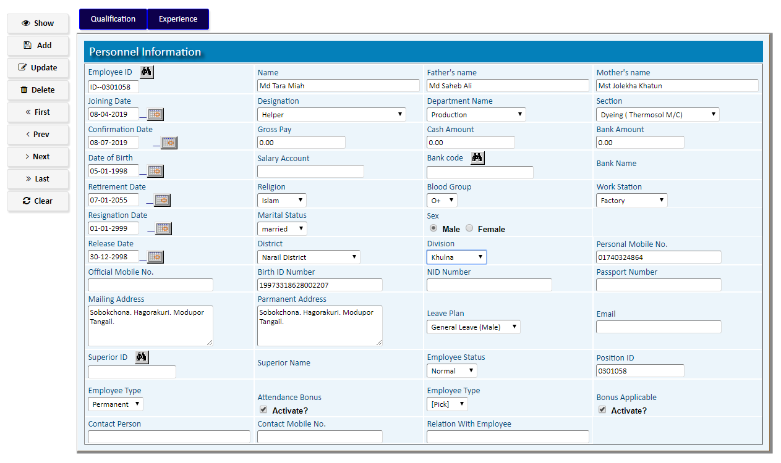

Click **Qualification** to Add Personnel Qualifications >>

1. Write Passing Year, Exam, Name of Institute, Major Subject, Result & then Click **Add**
2. Click **Return** after adding all Qualifications.

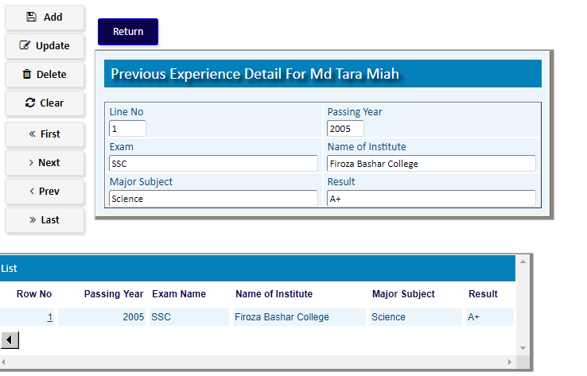

Click **Experience** to Add Personnel Experiences >>

1. Write a description of Previous Experience & then Click **Add**
2. Click **Return** after adding all Experiences.

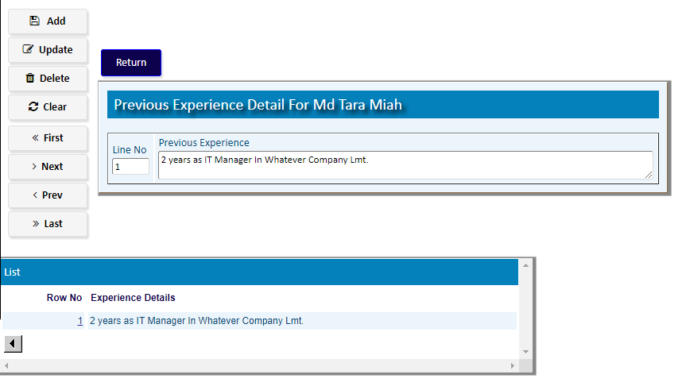

**Setting the Human Resources Department Codes & parameters**

|  |  |
| --- | --- |
| **Step 1** | Open System **>** HR & Payroll  **>** Human Resources Department > Setting |
| **Step 2** | Open the Desired Screen to set the required Code / Parameter |

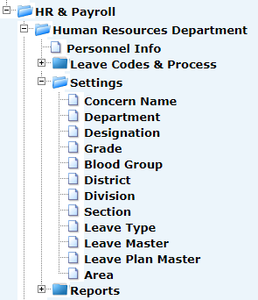

Department: write Department Name (Long Description), check the Activate & click **Add**

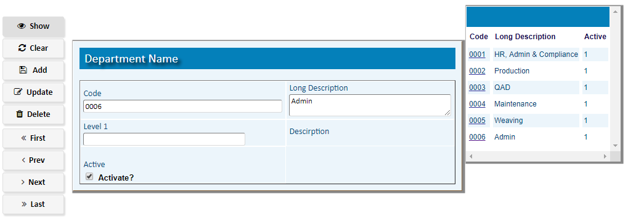

Designation: write Designation Name (Code), Department Name (Long Description), check the Activate & click **Add**

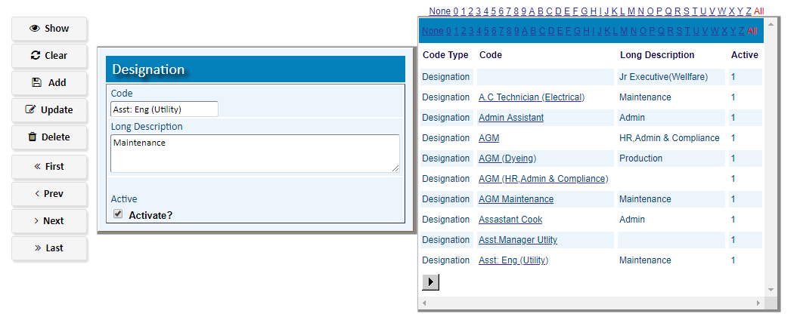

**Payroll**

**For Factory Payroll >>** Open System **>** HR & Payroll **>** FactoryPayroll

**For Head Office Payroll >>** Open System **>** HR & Payroll **>** Head Office Payroll

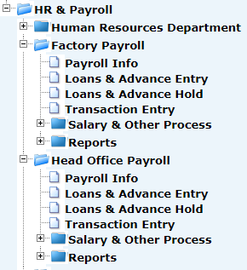

# Payroll Info

|  |  |
| --- | --- |
| **Step 1** | Open System **>** HR & Payroll  **>** FactoryPayroll/ Head Office Payroll **>** Payroll Info |
| **Step 2** | Choose Employee ID & then Click **Show** |
| **Step 3** | Write Bank Account, Gross Pay & other fields; then Click **Update** |
| **Result** | A new personnel info for Payroll will be added. |

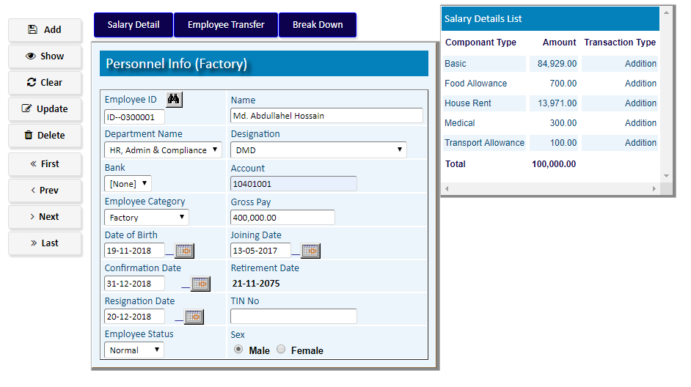

Click **Salary Detail** button to add the Component Types of salary >>

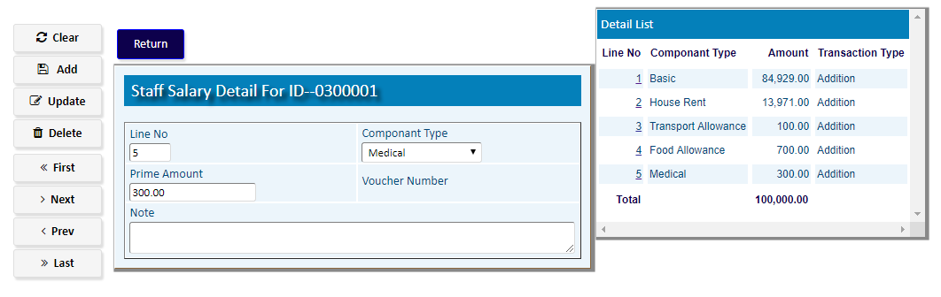

Click **Employee Transfer** button to transfer (Department & Position) the Staff >>

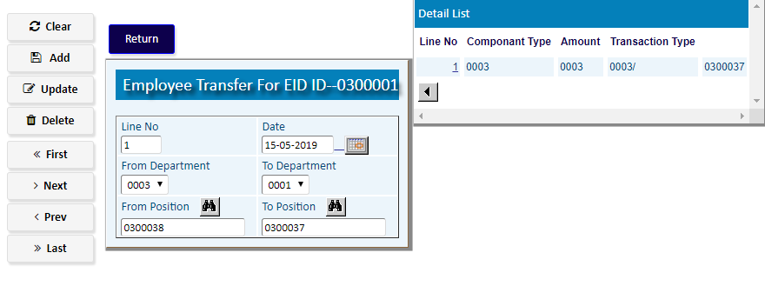

# Loans & Advance entry

|  |  |
| --- | --- |
| **Step 1** | Open System **>** HR & Payroll  **>**  FactoryPayroll/ Head Office Payroll **>** Loans & Advance Entry |
| **Step 2** | Select Employee ID |
| **Step 3** | Write the Loan type, Amounts , Effectivity Date etc. |
| **Step 4** | Click **Add** |
| **Result** | A new Loan Entry will be Added. |

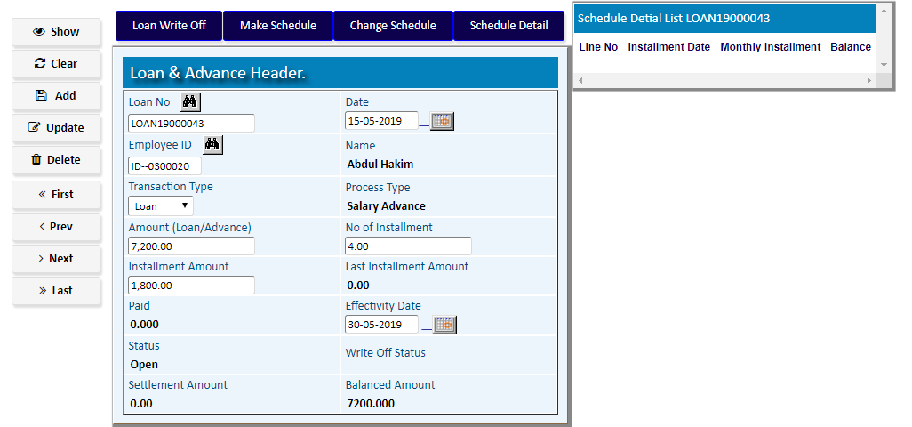

|  |  |
| --- | --- |
| **Step 4** | Click **Make Schedule** to add Schedule Detail for the Loan |

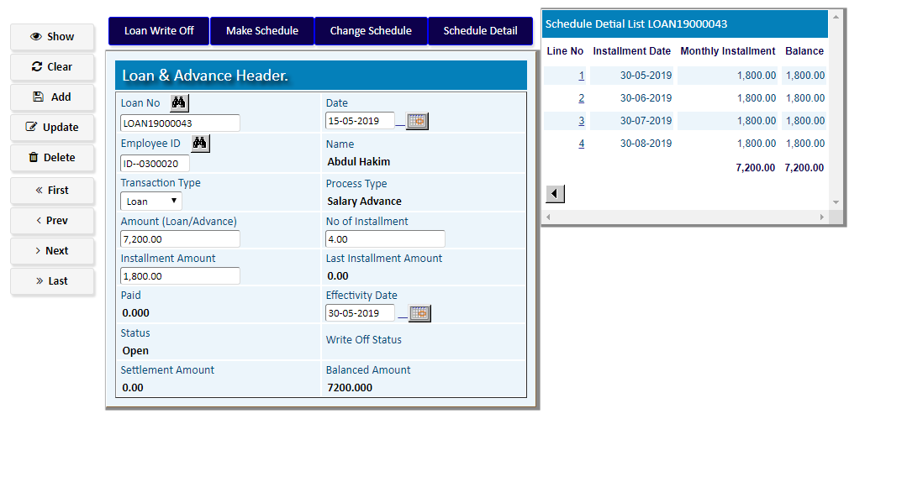

|  |  |
| --- | --- |
| **Step 4** | Click **Schedule** **Detail** to add or modify Schedule Detail for the Loan |

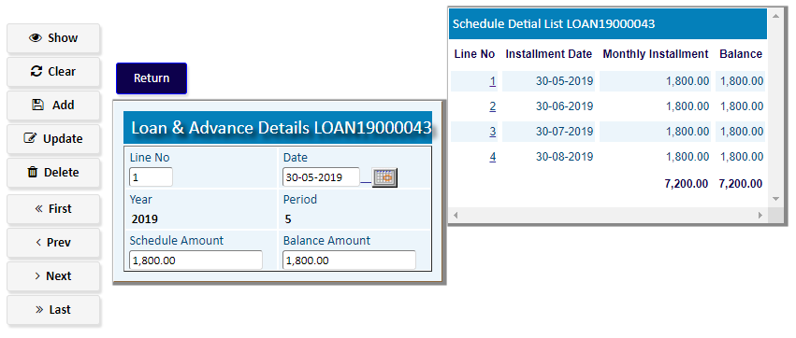

# Loans & Advance Hold

|  |  |
| --- | --- |
| **Step 1** | Open System **>** HR & Payroll  **>**  FactoryPayroll/ Head Office Payroll **>** Loans & Advance Hold |
| **Step 2** | Select Employee ID |
| **Step 3** | Write the Loan type, Amounts , Effectivity Date etc. |
| **Step 4** | Click **Add** |
| **Result** | A new Loan Entry will be Added. |

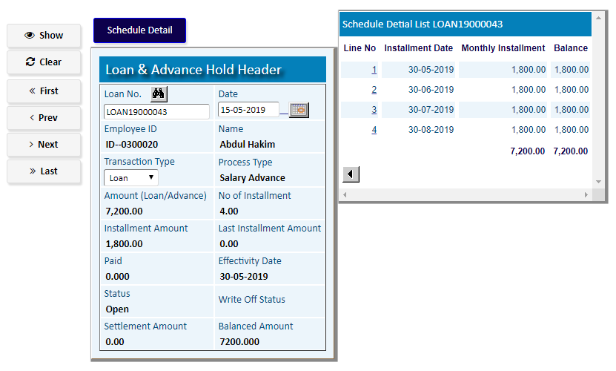

Click **Schedule** **Detail** to add or modify Schedule Detail for the Loan

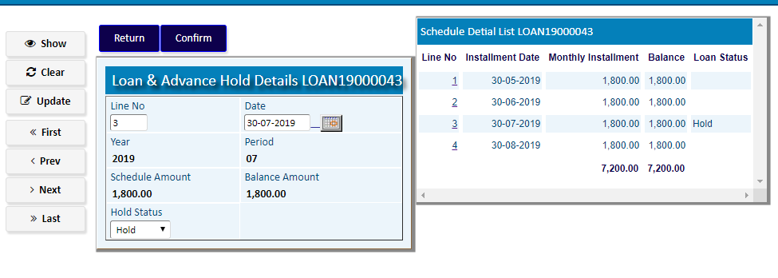

# Transaction Entry

|  |  |
| --- | --- |
| **Step 1** | Open System **>** HR & Payroll  **>** Payroll **>** Transaction Entry |
| **Step 2** | Select Date & Transaction Type |
| **Step 4** | Click **Add** |
| **Step 4** | Click **Detail** Buttonto add transaction details |
| **Result** | A new Transaction of Payroll Entry will be Added. |

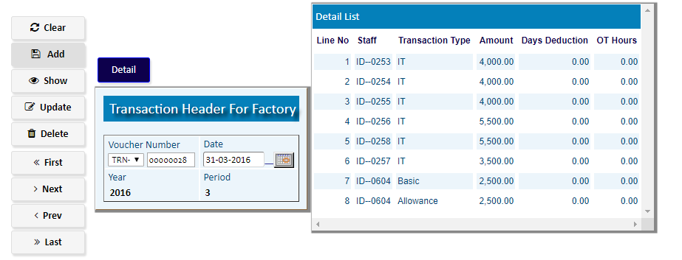

# Salary Process

|  |  |  |
| --- | --- | --- |
| **Step 1** |  | Open System **>** HR & Payroll **>** FactoryPayroll/ Head Office Payroll **>** Salary & Other Process |
| **Step 2** |  | Select a Process option. |
| **Step 3** |  | Select the start ID, end ID & other fields (Year, Period) to make process. |
| **Step 4** |  | Click **“Process”** button to execute the desired process. |
| **Result** |  | The process will be executed. |

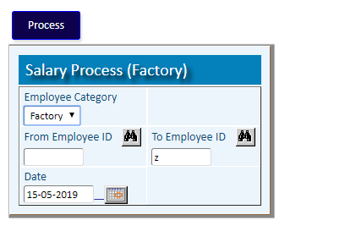

# Bonus Process

|  |  |  |
| --- | --- | --- |
| **Step 1** |  | Open System **>** HR & Payroll **>** FactoryPayroll/ Head Office Payroll **>** Salary & Other Process |
| **Step 2** |  | Select a Process option. |
| **Step 3** |  | Select the start ID, end ID & other fields (Year, Period) to make process. |
| **Step 4** |  | Click **“Process”** button to execute the desired process. |
| **Result** |  | The process will be executed. |

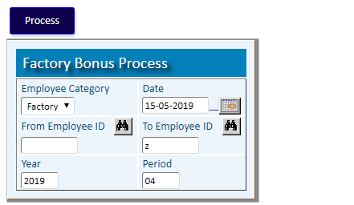

# Salary Process Close

|  |  |  |
| --- | --- | --- |
| **Step 1** |  | Open System **>** HR & Payroll **>** FactoryPayroll/ Head Office Payroll **>** Salary & Other Process |
| **Step 2** |  | Select a Process option. |
| **Step 3** |  | Select the start ID, end ID & other fields (Year, Period) to make process. |
| **Step 4** |  | Click **“Process”** button to execute the desired process. |
| **Result** |  | The process will be executed. |

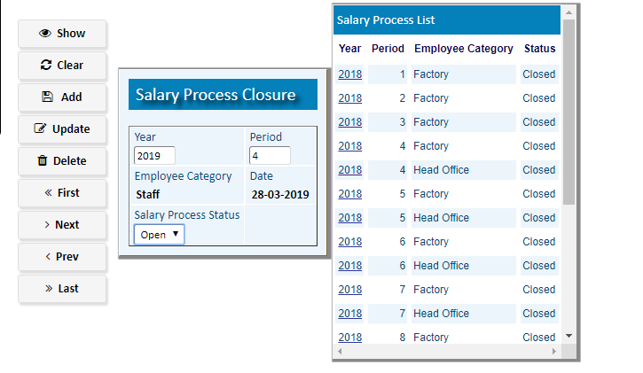

# Reports

### Printing report to preview data

|  |  |
| --- | --- |
| **Step 1** | Open System **>** HR & Payroll **>** Reports |
| **Step 2** | Select a report option. |
| **Step 3** | Select the start date, end date & other fields to specify data previewing in the report. |
| **Step 4** | Click **“View Report”** to preview in print format. |
| **Result** | The report is previewed in print format. |

